N°. 531300-LLP-1-2012-1-GR-KA3-KA3NW | DigiSkills: Network for the enhancement of digital  competence skills

DigiSkills

D 5.5 Final Evaluation Report of DigiSkills

Project: | N°. 531300-LLP-1-2012-1-GR-KA3-KA3NW
Work package: | WP5 Evaluation
PARTNER: | CTI
Authors: | Catherine Christodoulopoulou
Document Type: | Report
Distribution: | Public
Status: | Final
Document file: | D5_5_ Final Evaluation Report of DigiSkills
Version: | 0.1
Date: | 27 November 2015
Number of pages: | 34

Versions of the Document

Version | Date | Contributor | Summary of Changes
0.1 | 27/11/2015 | CTI

This project has been funded with the support of Lifelong Learning program of the European Union. This publication reflects the views only of the author, and the Commission cannot be held responsible for any use which may be made of the information contained therein.

Table of Contents

1 Overview of PHASE A 5
2 Overview of PHASE B 6
3 Digiskills Platform 9
4 The Additional implementation-evaluation action 14
5 Best Practices: Evaluation of the impact 21
5.1 Selected BP1: Easy Java Simulations for Inquiry Based Learning in STEM Disciplines 22
5.2 Selected BP2: Nanotechnology and Nanocomputers 24
5.3 Selected BP3: Marketing in the Internet 25
5.4 Selected BP4: Teaching & Learning with iPADs in competence-based Science Teaching................. 26
5.5 Selected BP5: Wiki training scenarios, a Pedagogical Framework fostering Wiki uses............ 27
5.6 Selected BP6: Safer Internet 29
6 DigiSkills ODC Communities 30
7 Conclusion 31

Scope of the Document

This document is a comprehensive evaluation report for the Implementation, covering both implementation and validation phases (PHASE A & PHASE B).
The document presents the overview of PHASE A and of PHASE B. In addition, it presents the evaluation of Digiskills platform as well as the evaluation of the additional implementation activities conducted by Digiskills consortium (online evaluation questionnaires and creation of sub-communities in Digiskills ODS community)

1 Overview of PHASE A
PHASE A was dealing with local level implementation activities and lasted from middle 2014 up to end of 2014. Each partner, based on the specific needs of his/her country (as arisen from the analysis during WP2) selected the appropriate type of activity as well as the appropriate Date in order to present the selected Best practices to selective local target group aiming at facilitating participants to familiarize themselves with the concept of good practices in addition to the Digiskills Platform.
PHASE A aiming at familiarizing SE, HE and AE teachers with the concept of good practices and the suitable validation process. This way, they will be prepared to test and evaluate the collected good practices. Feedback on the good practices will be collected and shall lead in the selection of those practices that stand out.
At this Phase partners are expected to present their best practices (all or a selection of them) to their target groups and to study the impact of those best practices by collecting specific data. The presented Best Practices have to be already uploaded to Digiskills Platform.
The evaluation process of PHASE A was decided as following:
- The selected best practices were presented to the participants.
- The Digiskills Platform was introduce to the participants
The evaluation of the best practice via Digiskills platform based on the agreed criteria
- Transferable: methods and tools able to replicate
- Innovative: good ideas and practical
- Impact: have a strong effect on someone or something
- Availability: Characteristic of a resource that is committable, operable, or usable upon demand to perform its designated or required function. It is the aggregate of the resource's accessibility, reliability, sustainability, serviceability.
- Adaptability: Ability of an entity or organism to alter itself or its responses to the changed circumstances or environment. Adaptability shows the ability to learn from experience.
- Acceptability: capability by good quality of conforming to approved standards. The fact of being approved of and considered normal by most people; suitability.
- Effectiveness: The good practice must work and achieve results that are measurable. The proposed good practice must produce results with a reasonable level of resources and Date.
- Creativity: the use of imagination or original ideas to create something It may be useful in solving problems, communicating with others, and entertaining ourselves and others
- Collaborative: produced by or involving two or more parties working together
During PHASE A Digiskills Platform had:
- 561 users

- 3.132 page views
- Bounce range 68,07%
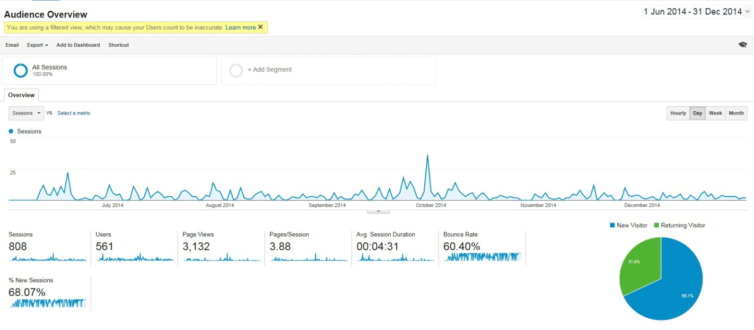
- Number of evaluated Best practices: 15
- Number of reached teachers: 284
Conclusion from PHASE A
PHASE A was the start point of the implementation phase of the project. During this Phase, the selected criteria of the Best practices were tested as well as the initial version of the Digiskills platform was tested. Overall, 15 Best practices were presented 284 teacher were reached. Moreover, during Phase A, 561 teachers visited and navigated to the Digiskills platform. In addition, the platform has 3.132 page views with a bounce range of 68,07%
Taking into consideration that the consortium expects to directly engage more than 1800 teachers, the implementation activities for PHASE B has to become more intense and more structured so as to boost the impact of the implementation activities and reach the foreseen number of teachers.

Overview of PHASE B
In PHASE B, the network of teachers that have participated in Phase A and more teachers from other partners and associated partners networks, will gather in a new round of activities to select the most outstanding best practices that will be circulated by DigiSkills at the end of the 3-year cycle of work.
DigiSkills platform played a crucial role in this Phase since it acted as the tool upon which the implementation of this Phase took place.
In particular, as resulted from PHASE A, The feedback for the implementation activities of PHASE B has to come through Digiskills platform. In addition, the evaluation of PHASE B will indicate the improvement of the digital skills of the participants and the adoption of the best practices in their professional environment
To this end, an evaluation questionnaire was developed for PHASE B. The questionnaire examined both the platform and the content of the best practices
The questions for platform are:
- I found that the Platform design is user-friendly and I can easily track, navigate and find information
- I found that the Platform has a nice web-design
- I think I will recommend Digiskills platform to others for searching Best Practices
- I think that an information provider like DigiSkills can be helpful toward finding new ideas
- I found the various functions in this Platform were well integrated
- I found that the User Menu of the platform is clear and easy use
- I found that the Manuals and Helpdesk of the platform are useful and helpful.
- I found that the FAQ are useful and helpful
The questions about the Best practice are:
For teachers:
- The Best Practice improved your ICT skills
- The Best practices can be incorporated in the framework of your every day professional activity (you can use a given scenario in your class)
- You will recommend the Best Practice in the framework of Digiskills to your colleagues
For students:
- The Best Practice improved your ICT skills
- The Best Practice, has increased your interest in this field of study
- You find the Best Practice easy to follow
- The knowledge you gain from the Best Practice has been effective in advancing your learning
In this Phase partners organized implementation events in which the selected Best Practices were presented and evaluated by all involved end users (SE, HE and AE teachers and students) through the use of the platform. At the same time, the participants were asked to fill the evaluation questionnaire of Digiskills
During PHASE B Digiskills Platform had:
2.019 users
13.064 page views
Bounce range 48,55%
Returning visitors 40,6%
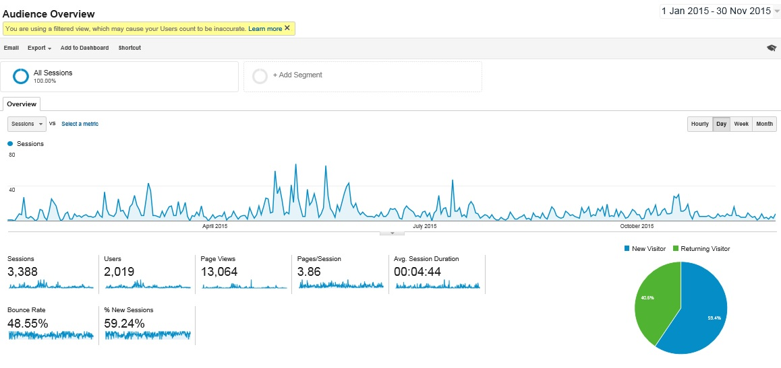
Number of evaluated Best practices: 13
Number of reached teachers & students: 1123
Conclusion
PHASE B was the core stage of the implementation phase of the project. During this Phase, the improvement of the digital skills of the participants and the adoption of the best practices in their professional environment were evaluated as well as the effectiveness of the Digiskills platform was tested in partners’ countries.
In particular
93,22% of the reached teachers and students strongly agreed and somehow agreed that the Platform design is user-friendly
92.86% of the reached teachers and students strongly agreed and somehow agreed that they recommend Digiskills platform to others for searching Best Practices
91,43% of the reached teachers and students strongly agreed and somehow agreed that an information provider like DigiSkills can be helpful toward finding new ideas
With respect to the reached teachers
87,10% agreed and somehow agreed that the Best Practice improved their ICT skills
93,55% agreed and somehow agreed that Best practices can be incorporated in the framework of your every day professional activity
90,32% and somehow agreed that they will recommend the Best Practice in the framework of Digiskills to your colleagues
With respect to the reached students:
85,71% agreed and somehow agreed that the Best Practice improved their ICT skills
85,71% agreed and somehow agreed that the Best Practice, has increased their interest in this field of study
100 % agreed and somehow agreed that the Best Practice easy to follow
100 % agreed and somehow agreed that the knowledge they gain from the Best Practice has been effective in advancing their learning
Overall, 13 Best practices were presented 1123 teachers and students were reached. Moreover, during Phase B, 2.019 teachers and students visited and navigated to the Digiskills platform. In addition, the platform has 13.064 page views with a bounce range of 48,55% and 40.6% returning visitors
Evaluation of Best Practice
The most important criterion of this Best practice is Availability 48,65%

Digiskills Platform
Short description of main functionalities
Digiskills Platform ( www.digiskills-project.eu ) is a social platform where teachers, students, parents and other community members will be able to discover, acquire, discuss and adapt eLearning resources on their topics of interest.

Digiskills Platform users

There are 2 types of users in DigiSkills platform: the registered users and the visitors

Registered users can

Share (upload) their best practices in a structure way:
- Key Information of your practice
- Details of your practice
- Author’s recommendations and further credits
- Upload files and other media to this practice
- About you (the author)

ALL users (registered and Visitors) can:
Search for uploaded best practices per the following filters:
- Title
- Keyword
- Country
- Educational level
- Evaluation criteria
- Area of good practice

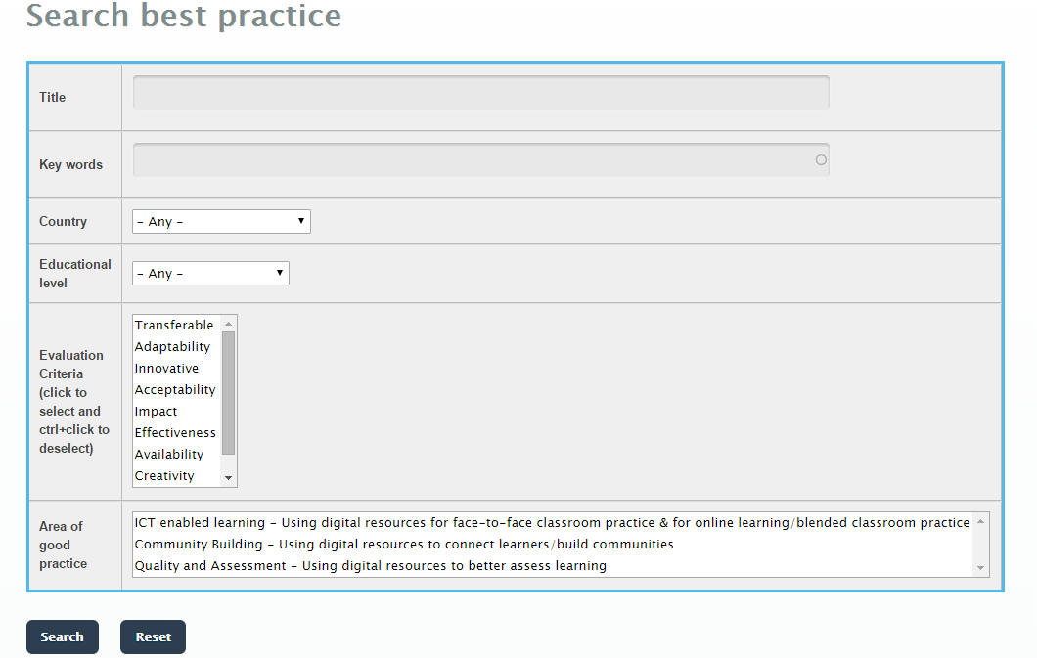

Browse all uploaded best practices by using the following filters:
- Educational level
- Target group
- Country
The screenshots below shows the browse form:
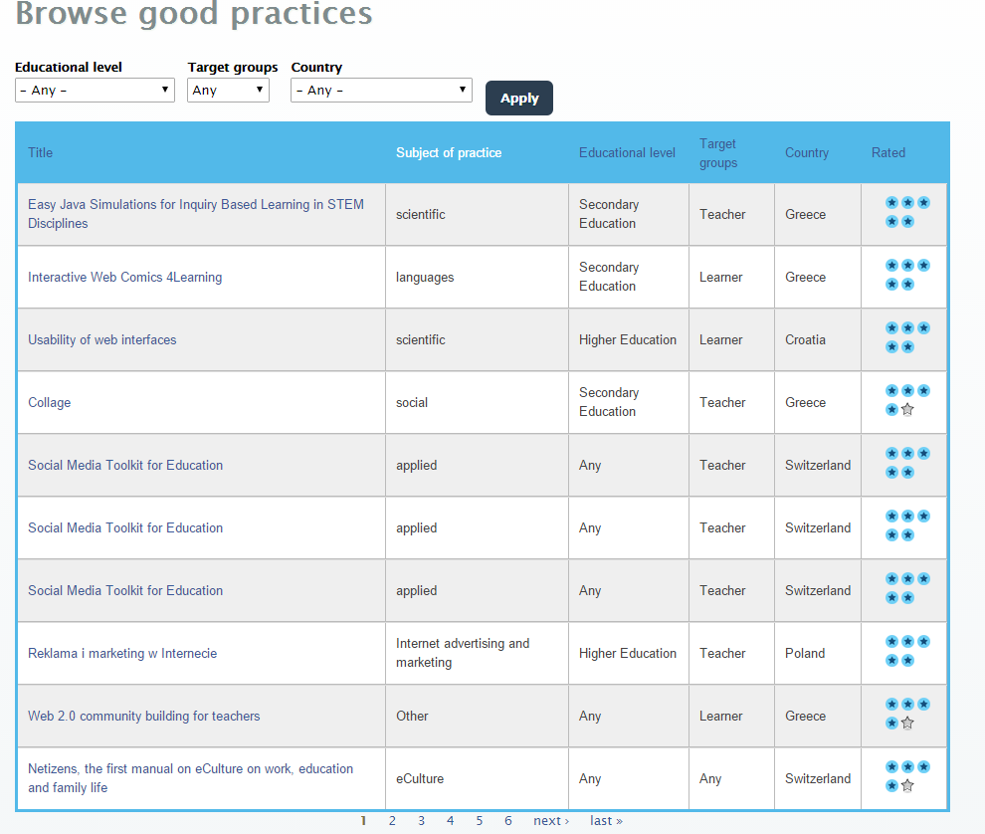
Evaluate best practice by star rating system OR by specific criteria:
Users can evaluate best practices by using the star rating system that can be found at the end of any best practice. Furthermore, the platform enables users to evaluate a best practice based on specific criteria. NOTE: each user can vote only one time per best practice (unique vote). The screenshot below shows the evaluation section of a best practice.
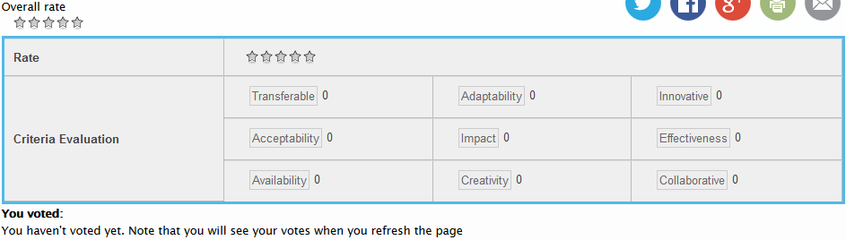
Data from the Digiskills Platform

Number of registered users: 276
Number of uploaded Best Practices: 58 Best Practices

Uploaded Best Practices per COUNTRY:
Country | number of Best practices
Greece | 15
Austria | 7
Spain | 8
Poland | 6
Italy | 1
Croatia | 7
France | 1
Switzerland | 4
UK | 5
Hungary | 3
Belgium | 1
total | 58

Uploaded Best Practices per EDUCATIONAL LEVEL:
Educational Level | number of Best practices | url
Any | 6 | http://www.digiskills-project.eu/?q=search-best-practice&title=&field_key_words_tid=&field_country_value=All&field_educational_level_value=any&field_translated_versions_fid=&=Search
Secondary Level | 37 | http://www.digiskills-project.eu/?q=search-best-practice&title=&field_key_words_tid=&field_country_value=All&field_educational_level_value=SE&&&field_translated_versions_fid=
Higher education | 13 | http://www.digiskills-project.eu/?q=search-best-practice&title=&field_key_words_tid=&field_country_value=All&field_educational_level_value=HE&&&field_translated_versions_fid=
Adult Education | 2 | http://www.digiskills-project.eu/?q=search-best-practice&title=&field_key_words_tid=&field_country_value=All&field_educational_level_value=AE&field_translated_versions_fid=&=Search
total | 58

Evaluation and vote of Best Practices
All users (registered and visitors) evaluated the uploaded Best Practices both per criteria per Best practice and by overall rate the best practices. However, the vast majority of the users chose to evaluate the criteria of the Best practices rather than rate them. In particular,
Counted votes for registered users, per criteria for ALL uploaded Best Practices= 559
evaluation criteria | votes (registered user)
transferable | 85
availability | 68
creativity | 63
adaptability | 62
acceptability | 61
effectiveness | 61
innovative | 57
collaborative | 51
impact | 51
total | 559

With respect to visitors (anonymous users) the counted votes per criteria for ALL uploaded Best Practices=3.726

evaluation criteria | votes (visitors-anonymous users)
availability | 1.874
transferable | 283
adaptability | 253
acceptability | 232
creativity | 223
impact | 224
innovative | 226
collaborative | 209
effectiveness | 202
total | 3.726

With respect to Total counted votes (unique votes) per criteria for ALL uploaded Best Practices by all users (registered and visitors) are 4.285
evaluation criteria | votes (all users)
availability | 1.942
transferable | 368
adaptability | 315
creativity | 294
acceptability | 285
innovative | 273
effectiveness | 273
impact | 269
collaborative | 266
total | 4.285

45.32% of the users evaluated as the most important is Availability which has defined as: Characteristic of a resource that is committable, operable, or usable upon demand to perform its designated or required function. It is the aggregate of the resource's accessibility, reliability, sustainability, serviceability.

Digiskills Overall data from Google Analytics
During the implementation phase (PHASE A & PHASE B) the platform had:
2.568 users
16.196 pages views
Bounce range: 50,83%
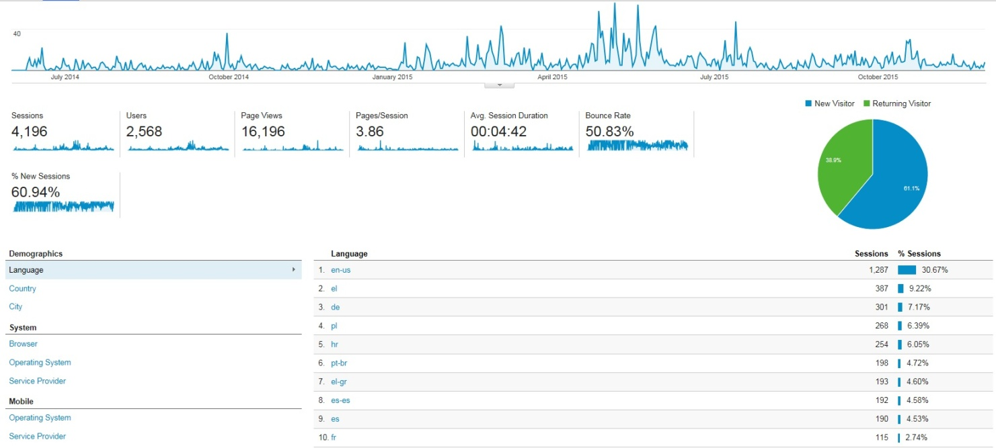

The Additional implementation-evaluation action
In parallel with PHASE B the consortium decided to launch an online evaluation process address to target group and potential target groups of partners.
The additional online implementation-evaluation action took place from the middle of PHASE B and ended after the final conference of Digiskills.
For this action, the evaluation questionnaire that was created for PHASE B became available online through the platform. Partners informed their potential target groups (teachers and students). In addition, immediately after the final conference of Digiskills EDEN invited the participated teachers and students of Digiskills final conference to visit the platform and to vote/rate on the digital resources
Results from that additional evaluation action

Number of people who filled the questionnaire: 102 (78 teachers and 24 students)
Evaluation of the platform
47,06% strongly agree and 33,33% somewhat agree (total 80,39%) that the Platform design is user-friendly

49,02% strongly agree and 37,25%somewhat agree (total 86,27%) that they will recommend Digiskills platform to others for searching Best Practices

56,86% strongly agree and 25,49% somewhat agree (total 82.35%) that an information provider like DigiSkills can be helpful toward finding new ideas

Summary of all answers with respect to evaluation of Digiskills Platform

Evaluation of the participated TEACHERS of the impact of Best Practices
Number of participated teachers: 78
32,05% of the participated teachers were advanced ICT users whereas the 35,90% were rather advanced ICT user

43,59% strongly agreed and 29,49% somewhat agreed (total 73,08%) that the Best Practice improved their ICT skills

39,74% strongly agreed and 41,03% somewhat agreed (total 80,77%) that they can incorporated the Best practice in the framework of their every day professional activity

55,13% strongly agreed and 28,21% somewhat agreed (total 83,33%) that they will recommend the Best Practice in the framework of Digiskills to their colleagues

Evaluation of the participated STUDENTS of the impact of Best Practices
Number of participated students:24
25% of the participated students were advanced ICT users whereas the 37,50% were rather advanced ICT user

41,67% strongly agreed and 33,33 % somewhat agreed (total 75 %) that the Best Practice improved their ICT skills

25% somewhat agreed and 50% somewhat agreed (total 75 %) that the Best Practice, has increased their interest in this field of study

25 % strongly agreed and 54,17 %somewhat agreed (total 79.17%) that the Best Practice was easy to follow

37,50 % strongly agreed and 33,33 % somewhat agreed (total 70,83%) that the knowledge they gain from the Best Practice has been effective in advancing their learning

Best Practices: Evaluation of the impact
As a last stage of the implementation phase, DigiSkills consortium decided to examine the Best practices presented in PHASE A as well as of the ones presented in PHASE B and select the six most “popular” in term of voting per criterion and of overall rating. The primarily principle for the final selection was the number of votes per evaluation criterion since the majority of evaluators concentrated on voting the criteria and not so much on rating the Best practices

Selected Best Practices based on number of votes per criteria

BP per numbers of votes per evaluation criterion | number of votes
Easy Java Simulations for Inquiry Based Learning in STEM Disciplines | 268
Nanotechnology and Nanocomputers | 261
Marketing in the Internet | 260
Teaching & Learning with iPADs in competence-based Science Teaching | 259
Wiki training scenarios, a Pedagogical Framework fostering Wiki uses | 258
Safer Internet | 258

Selected Best Practices based on counted five stars (rating): how many times they were voted with 5 stars
BP PER COUNTED FIVE STARS- how many times they were voted with 5 stars | counted five stars
Easy Java Simulations for Inquiry Based Learning in STEM Disciplines | 12
Safer Internet | 7
Marketing in the Internet | 5
Teaching &Learning with iPADs in competence-based Science Teaching | 4
Nanotechnology and Nanocomputers | 4
Wiki training scenarios, a Pedagogical Framework fostering Wiki uses | 1

Selected BP1: Easy Java Simulations for Inquiry Based Learning in STEM Disciplines
Number of votes: 268
Criteria Evaluation | Votes
Transferable | 41
Acceptability | 26
Availability | 40
Adaptability | 29
Impact | 24
Creativity | 32
Innovative | 26
Effectiveness | 30
Collaborative | 20
total votes | 268

Page views: 190
Unique page views: 109
Evaluation of impacts
Transferable (methods and tools able to replicate) is the most characteristic impact of this BP (15,30%).
Availability (Characteristic of a resource that is committable, operable, or usable upon demand to perform its designated or required function) is also an important impact for this BP (14,93% )
Creativity (the use of imagination or original ideas to create something) is also an important impact for this BP (11,94%)
Effectiveness (The good practice must work and achieve results that are measurable) is an equally important impact for this BP (11,94%)

Selected BP2: Nanotechnology and Nanocomputers
Number of votes: 261
Criteria Evaluation | Votes
Transferable | 40
Acceptability | 35
Availability | 67
Adaptability | 25
Impact | 14
Creativity | 28
Innovative | 20
Effectiveness | 13
Collaborative | 19
total votes | 261

Page views:187
Unique page views: 107
Evaluation of impacts
Availability (Characteristic of a resource that is committable, operable, or usable upon demand to perform its designated or required function) is the most characteristic impact of this BP (25,67%).
Transferable (methods and tools able to replicate) is also an important impact for this BP (15,33% )
Acceptability (capability by good quality of conforming to approved standards) is also an important impact for this BP (13,41%)

Selected BP3: Marketing in the Internet
Number of votes: 260

Criteria Evaluation | Votes
Transferable | 35
Acceptability | 30
Availability | 45
Adaptability | 38
Impact | 28
Creativity | 28
Innovative | 20
Effectiveness | 18
Collaborative | 18
total votes | 260

Page views: 188
Unique page views: 108
Evaluation of impacts
Availability (Characteristic of a resource that is committable, operable, or usable upon demand to perform its designated or required function) is the most characteristic impact of this BP (17,31%)
Adaptability (Ability of an entity or organism to alter itself or its responses to the changed circumstances or environment) is also an important impact for this BP (14,62%)
Transferable (methods and tools able to replicate) is also an important impact for this BP (13,46%)
Acceptability (capability by good quality of conforming to approved standards) is also an important impact for this BP (11,54%)

Selected BP4: Teaching & Learning with iPADs in competence-based Science Teaching
Number of votes: 259

Criteria Evaluation | Votes
Transferable | 36
Acceptability | 36
Availability | 70
Adaptability | 36
Impact | 20
Creativity | 8
Innovative | 21
Effectiveness | 11
Collaborative | 21
total votes | 259

Page views: 186
Unique page views: 106

Evaluation of impacts
Availability (Characteristic of a resource that is committable, operable, or usable upon demand to perform its designated or required function) is the most characteristic impact of this BP (27,03%
Transferable (methods and tools able to replicate) is also an important impact for this BP (13,90%
Acceptability (capability by good quality of conforming to approved standards) is also an important impact for this BP (13,90%)
Adaptability (Ability of an entity or organism to alter itself or its responses to the changed circumstances or environment) is an equal important impact for this BP (13,90%)

Selected BP5: Wiki training scenarios, a Pedagogical Framework fostering Wiki uses
Number of votes: 258

Criteria Evaluation | Votes
Transferable | 34
Acceptability | 25
Availability | 55
Adaptability | 31
Impact | 30
Creativity | 20
Innovative | 22
Effectiveness | 21
Collaborative | 20
total votes | 258

Page views: 186
Unique page views: 107
Evaluation of impacts
Availability (Characteristic of a resource that is committable, operable, or usable upon demand to perform its designated or required function) is the most characteristic impact of this BP (21,32%)
Transferable (methods and tools able to replicate) is also an important impact for this BP (13,18%)
Adaptability (Ability of an entity or organism to alter itself or its responses to the changed circumstances or environment) is also an important impact for this BP (12,02%%)
Impact (have a strong effect on someone or something) is also an important impact for this BP (11,63%)

Selected BP6: Safer Internet
Number of votes: 258
Criteria Evaluation | Votes
Transferable | 21
Acceptability | 20
Availability | 50
Adaptability | 30
Impact | 27
Creativity | 26
Innovative | 26
Effectiveness | 26
Collaborative | 32
total votes | 258

Page views: 185
Unique page views:105
Evaluation of impacts
Availability (Characteristic of a resource that is committable, operable, or usable upon demand to perform its designated or required function) is the most characteristic impact of this BP (19,38%)
Collaborative (produced by or involving two or more parties working together) is also an important impact for this BP (12,40%)
Adaptability (Ability of an entity or organism to alter itself or its responses to the changed circumstances or environment) is also an important impact for this BP (11,63%)
Impact (have a strong effect on someone or something) is also an important impact for this BP (10,47%

DigiSkills ODC Communities
An additional action toward the effective completion of implementation activities was the involvement of ODS communities within the framework of PHASE B
Partners visited the Digiskills community on ODS and created a sub community for each best practice that they were implementing. The created communities along with the number of reached teachers
Name of the Community | Members | responsible partner
Network for the enhancement of digital competence skills – DigiSkills | 19 | EA
iPads in competence-based science education | 2 | BMBF
Nanotechnology and Nanocomputers | 7 | USP
Inspiring Science Education - ISE Contest implementation | 3 | EDEN
Social Media Toolkit for Education | 2 | EDEN
Easy Java Simulations for Inquiry Based Learning in STEM Disciplines | 414 | STEM-EA
Mobile Learning | 1 | BMBF
Multimedia Cards and Bookmarks | 3 | BMBF
Safer Internet | 10 | USP
GEOThinking Community | 699
Collage | 3 | EA
Digital Rural Schools | 2 | EA
Advertising and promotion of culture in Internet | 1 | MCSU
Achaia | 20 | CTI
TOTAL MEMBERS | 1186

Conclusion
The implementation phase of Digiskills project was expected to directly engage more than 1800 teachers.
In addition, the focus of the evaluation of DigiSkills Implementation phase was to evaluate the Digiskills platform as well as the the impact of the available best practices
The evaluation results show that:
During PHASE A 15 Best practices were presented 284 teacher were reached
During PHASE B 13 Best practices were presented 1123 teachers and students were reached.
From the Additional online evaluation action 102 teachers and students were reached
From the creation of sub-communities in Digiskills community on ODS 1186 teachers were reached
By the end of the project Digiskills Platform has 276 registered users and 58 uploaded Best Practices. Moreover, during the implementation phase of the project (PHASE A & PHASE B) 2.568 users visited the platform. The page views of the platform is 16.196 and its Bounce range is 50,83% In addition,
- 47,06% strongly agree and 33,33% somewhat agree (total 80,39%) that the Platform design is user-friendly
- 49,02% strongly agree and 37,25%somewhat agree (total 86,27%) that they will recommend Digiskills platform to others for searching Best Practices
- 56,86% strongly agree and 25,49% somewhat agree (total 82.35%) that an information provider like DigiSkills can be helpful toward finding new ideas

The evaluation criteria of the uploaded Best practices were voted by 4.285 users (registered and visitors). Moreover, 45.32% of the users evaluated as the most important is Availability which has defined as: Characteristic of a resource that is committable, operable, or usable upon demand to perform its designated or required function.
With respect to the participated teachers:
- 43,59% strongly agreed and 29,49% somewhat agreed (total 73,08%) that the Best Practice improved their ICT skills
- 39,74% strongly agreed and 41,03% somewhat agreed (total 80,77%) that they can incorporated the Best practice in the framework of their every day professional activity
- 55,13% strongly agreed and 28,21% somewhat agreed (total 83,33%) that they will recommend the Best Practice in the framework of Digiskills to their colleagues
With respect to the participated students:
- 41,67% strongly agreed and 33,33 % somewhat agreed (total 75 %) that the Best Practice improved their ICT skills
- 25% somewhat agreed and 50% somewhat agreed (total 75 %) that the Best Practice, has increased their interest in this field of study
- 25 % strongly agreed and 54,17 %somewhat agreed (total 79.17%) that the Best Practice was easy to follow
- 37,50 % strongly agreed and 33,33 % somewhat agreed (total 70,83%) that the knowledge they gain from the Best Practice has been effective in advancing their learning
With respect to the 6 selected Best Practices:

BP per numbers of votes per evaluation criterion | votes | most important criterion | (%)
Easy Java Simulations for Inquiry Based Learning in STEM Disciplines | 268 | Transferable | 15,30%
Nanotechnology and Nanocomputers | 261 | Availability | 25,67%
Marketing in the Internet | 260 | Availability | 17,31%
Teaching&Learning with iPADs in competence-based Science Teaching | 259 | Availability | 27,03%
Wiki training scenarios, a Pedagogical Framework fostering Wiki uses | 258 | Availability | 21,32%
Safer Internet | 258 | Availability | 19,38%

The TOTAL number of reached teachers and students is summarized below:
Implementation-evaluation activities | number of reached teachers/students
PHASE A | 284
PHASE B | 1123
online evaluation questionnaire | 102
ODC communities | 1186
TOTAL | 2695

From ISKE analytics report, the conclusions about the site architecture as well as about updating the Digiskills Google Analytics account to increase quality of data collection are:
Information Architecture
Evaluate search mechanism for Digiskills Search Bar
Analytics data suggests that the search by keyword in search bar is the least effective search feature for providing access to Best Practice Resources. The mechanism by which results are searched and returned to the user should be re-evaluated. This might mean updating this feature to allow keyword search over more available metadata fields for each Best Practice, as well as evaluating the way in which search results relevancy are determined. This will be of increasing importance if the number of resources on the Digiskills website grows.

Nest content types
Currently, URL patterns across the Digiskills website make it difficult to isolate traffic to specific content types. For example, the same search query parameter applies to Best Practice pages, as well as a number of other informational pages, such as the About Page and Partners Page. Adjusting URL structures to reflect more specific content types would allow Digiskills to more precisely monitor traffic to and engagement with different types of resources.

Update Evaluation Mechanism
Analytics data suggests that most people do not login before navigating to Best Practice content pages. Currently, there is no indication that users must login to evaluate resources. Additionally, users must refresh the page to view results. This makes it difficult to tell the difference between accidental and intentional resource evaluations. Creating simple form submit function would allows more clarity for users, as well as for website evaluators, and would make event tracking more efficient.

Add additional Event Tracking Code
Add event tracking for the following items:
Resource evaluations
Comments
Page scroll
*Page scroll event tracking will allow Digiskills website evaluators to more accurately assess time spent reading resource pages. This has been shown to increase accuracy of engagement metrics on non-transactional websites.

Google Analytics Account Updates

Remove or change analytics code on hermes.westgate.gr server
Currently, the same analytics tracking ID is being used on the staging server and the production server. I created segment filters to control for this, but it is likely that these filters were imperfect and that some traffic from the staging server was included in the reporting data.

Configure View Level Spam Filters
A Google Analytics account admin should configure spam filters at the View level. Spam filters were created at the Segment level, but this will become cumbersome and create extra sampling effect as the amount of Digiskills analytics data increases. Additionally, an account admin should monitor site traffic sources on a regular basis, to identify new potential sources of spam.

Configure Site Search Section
A Google Analytics account admin should add site search URLs to the Analytics account. This will allow more accurate tracking of sessions and users who search over longer periods of time. The segmenting approach used within this report is subject to data sampling. Data sampling will begin once the Digiskills site reaches 250,000 sessions.

Configure a User View and set a User Custom Dimension
The analytics code currently on the Digiskills website indicates that User ID is being tracked, which allows user data to be aggregated in the Digiskills Google Analytics. It may be useful to create a User Tracking View for the analytics account, which will allow more precise segmentation of user activity. Additionally, Digiskills may wish to create a Custom Dimension which allows tracking of individual users, or specific user groups. This is of course, must be non-identifiable to Google, but can be decoded using information from the Digiskills private user database.

Configure Goals and Goal Funnels
A Google Analytics Account Admin should configure Goals and expected paths to Goals. This will allow more precise comparison of expected and actual paths through the website. Again, using this feature at the View Level will reduce sampling effect which will occur at the segment Level.

